**Wire-Frame Design**

**Travel Data Analysis (Air BNB Case Studies)**

Last Revised Date: 10/10/2021

**Document Version Control**

|  |  |  |  |
| --- | --- | --- | --- |
| Version | Date | Author | Comments |
| 0.1 | 10-Oct-21 | Manish Tiwari  Samruddhi Deshmukh  Subhabrata Nath | Update Wireframe Design |
| 0.2 |  |  |  |
|  |  |  |  |

**Reviews:**

|  |  |  |  |
| --- | --- | --- | --- |
| Version | Date | Reviewer | Comments |
|  |  |  |  |

|  |  |  |  |  |
| --- | --- | --- | --- | --- |
| Version | Review Date | Reviewed By | Approved By | Comments |
|  |  |  |  |  |

**Approval Status:**

**1. Introduction**

Wireframe Design describes the Presentation structure of the analysis. Here we have shown the visualization and plotting we have created in order to find the relation between attributes.

As per the problem statement, we have build a Dashboard for the presentation of the analysis.

**2. Relations Between Different attributes.**

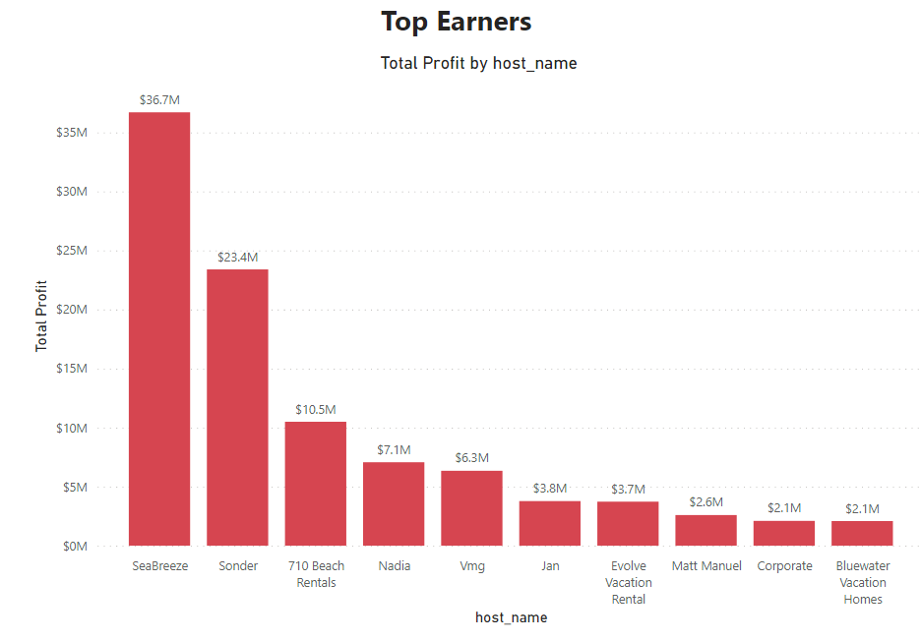**2.1 Top Earners (Host)**

We have created a Bar Graph by taking Hostname and Top Profit measures to find the Top Earners.

**2.2 Avg Price by City**

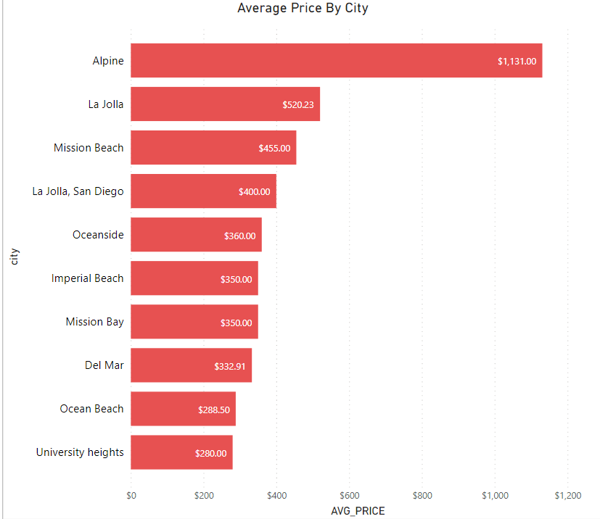

From the above plot, we can observe Average prices from a different city.

**2.3 Average Price by Property type.**

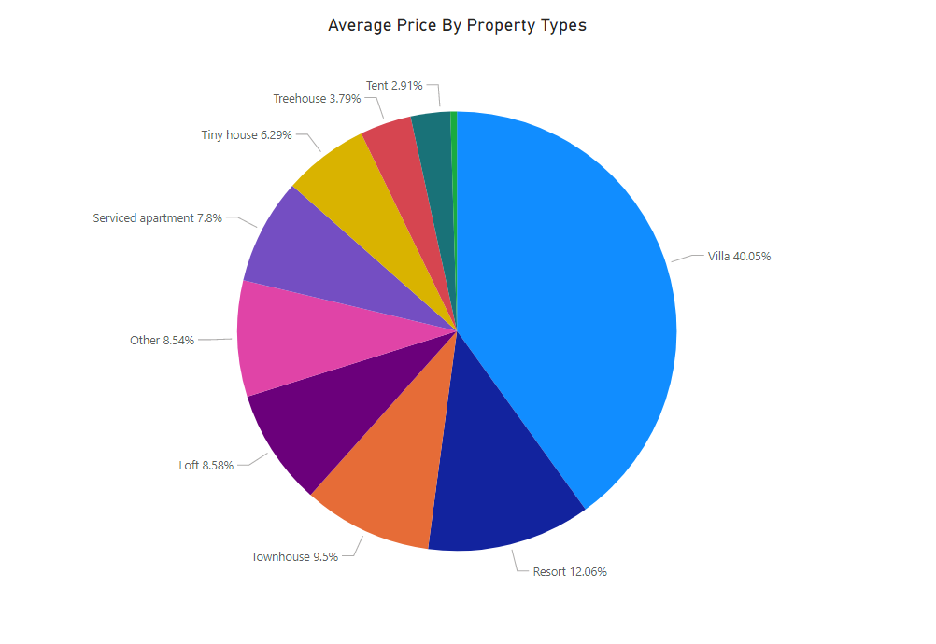

From the above Pie Chart, we can observe the average price occupied by different properties.

**2.4 Booking from different Places.**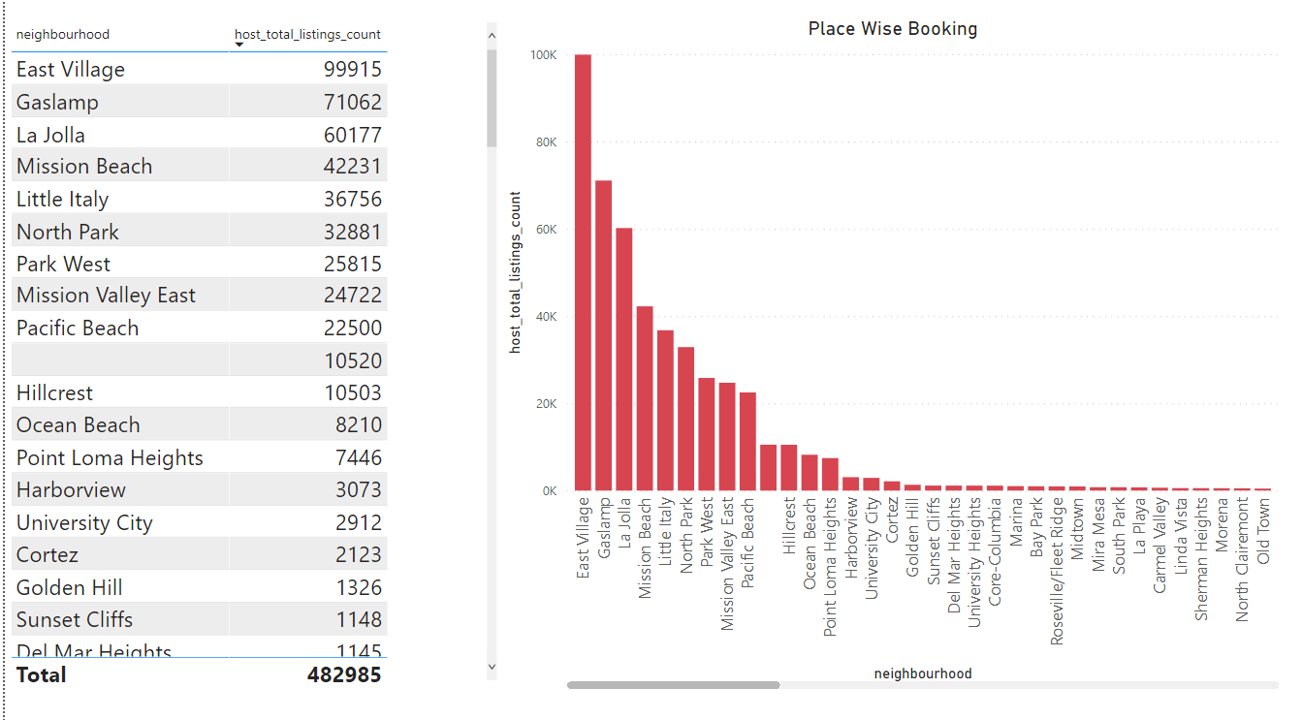

The above graph is created for observing from which place the maximum number of bookings is coming.

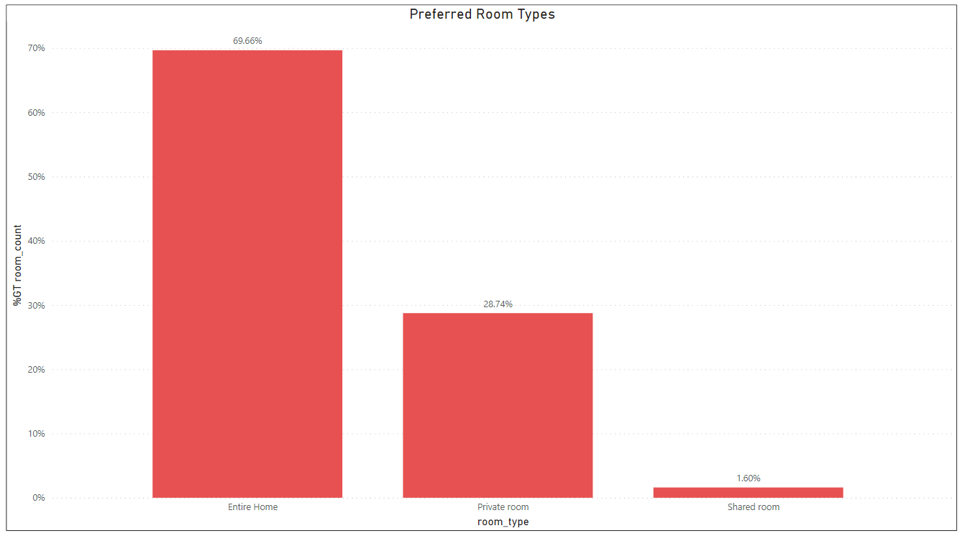**2.5 Preferred Room Type**

The above graph shows the demand for different room types.

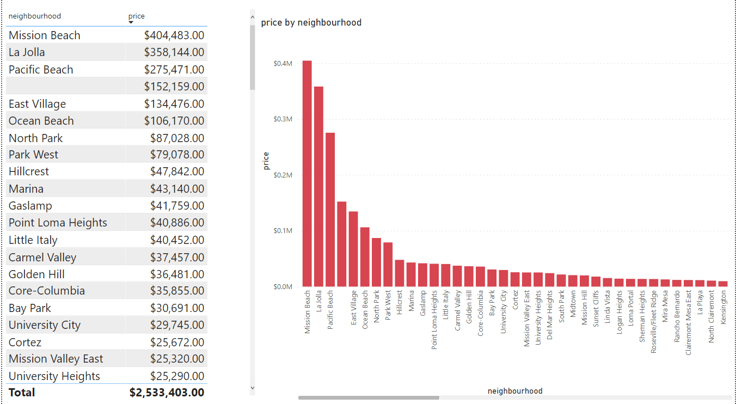**2.6 Price By Location(Neighborhood)**

From the above plot, we can analyze the price from different places.

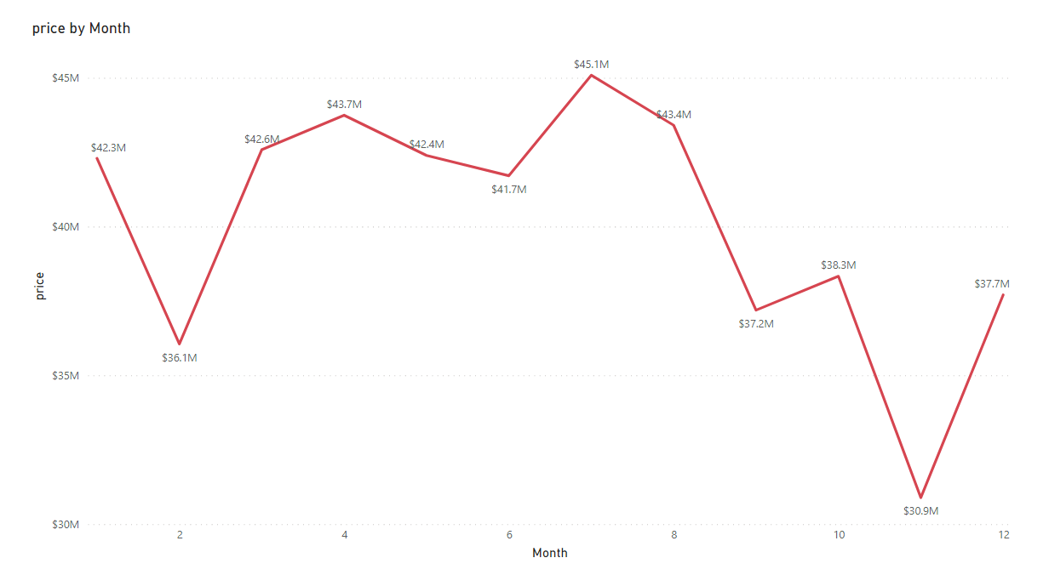**2.7 Price Change by Months**

From this Line plot, we can observe the relation the price changes with months.

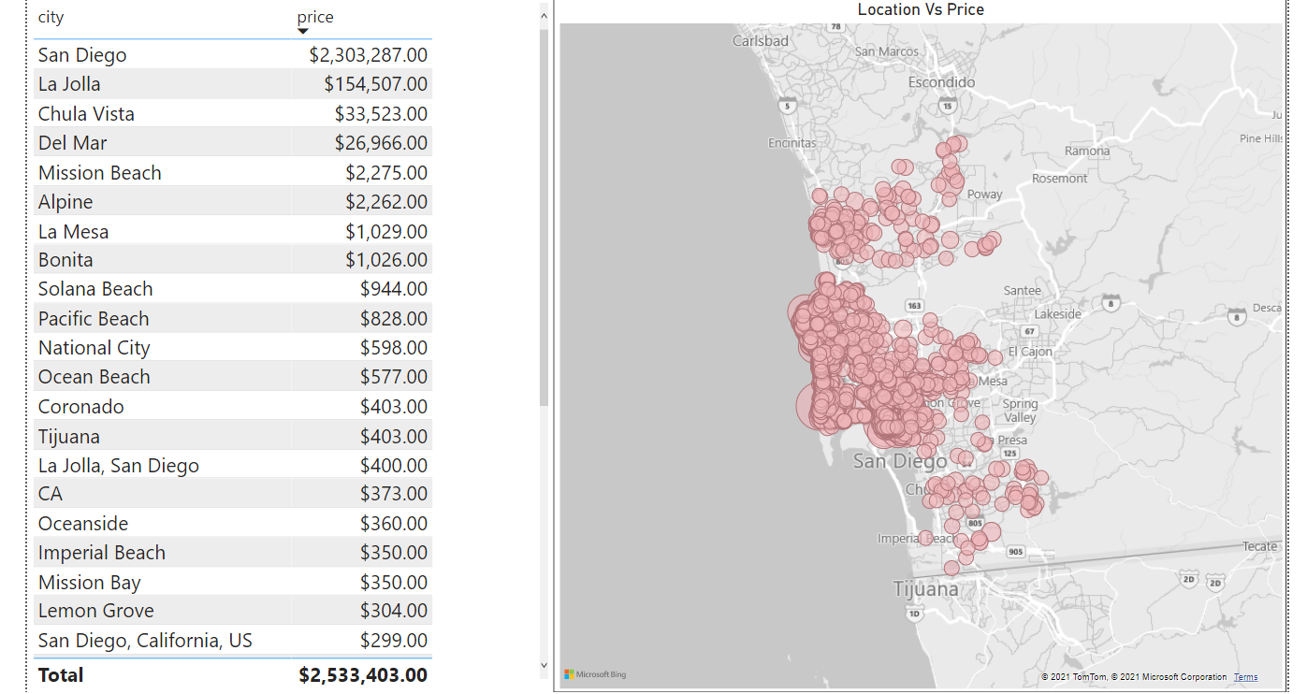2.8 Price by Location

The above graph is created by inserting **`latitude`** and **`longtitude`** available on the **`listing`** table.

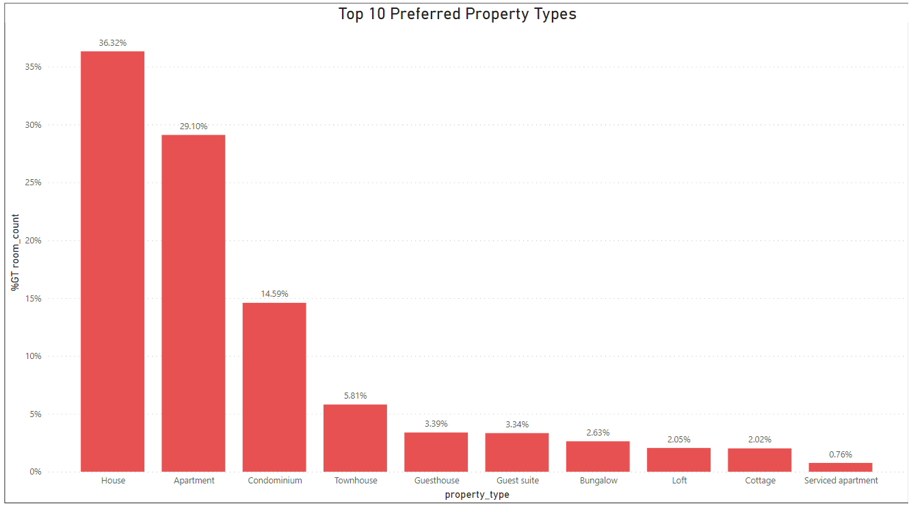**2.9 Top Preferred Property type**

From here we have shown the **top 10** preferred property types by tourists.